Garage Management System



# Project by,

**Name :** Vishwa Jothi A

**Mail ID :**vishwajothi585@gmail.com

**College :** Mahendra Engineering College(Autonomous), Namakkal.

# Index

| **S.No** | **Topics** | **Pg.No** |
| --- | --- | --- |
| 1. | Salesforce | 3 |
| 2. | Create developer account | 4 |
| 3. | Creating of Object | 5 |
| 4. | Creating the Custom tab | 6 |
| 5. | Creating a Lightning App | 7 |
| 6. | Creation of Fields | 7 |
| 7. | Create Validation Rule | 8 |
| 8. | Create Duplicate Rule | 9 |
| 9. | Create Profiles | 10 |
| 10. | Configure Reports and Dashboards | 11 |
| 11. | Setup Workflow rules and Automation | 12 |
| 12. | Customize Page Layouts | 12 |
| 13. | Create and Configure Email Template | 13 |
| 14. | Ensure Security and Access Control | 13 |
| 15. | Develop Custom Lightning Component | 13 |
| 16. | Testing and Deployment | 14 |
| 17. | Continuous Improvement and Maintenance | 15 |
| 18. | Output screenshot | 15 |
| 19. | Conclusion | 17 |

**Salesforce**

## Introduction:

Are you new to Salesforce? Not sure exactly what it is, or how to use it? Don’t know where you should start on your learning journey? If you’ve answered yes to any of these questions, then you’re in the right place. This module is for you.

Welcome to Salesforce! Salesforce is game-changing technology, with a host of productivity-boosting features, that will help you sell smarter and faster. As you work toward your badge for this module, we’ll take you through these features and answer the question, “What is Salesforce, anyway?” .

## What is salesforce:

Salesforce is your customer success platform, designed to help you sell, service, market, analyze, and connect with your customers. Salesforce has everything you need to run your business from anywhere. Using standard products and features, you can manage relationships with prospects and customers, collaborate and engage with employees and partners, and store your data securely in the cloud.

So what does that really mean? Well, before Salesforce, your contacts, emails, follow-up tasks, and prospective deals might have been organized something like this: <https://youtu.be/r9EX3lGde5k>

### Introduction

This document outlines the process of designing and implementing a Garage Management System using Salesforce. The goal is to streamline garage operations and enhance customer satisfaction by managing customer information, appointments , service records, billing details, and feedback efficiently.

### Create a developer account:

#### Sign-up:

First we want to sign-up to developer account, visit :( <https://developer.salesforce.com/signup>)

Fill out the sign-up form with the following details: - First Name and Last Name - Email Address - Role: Select “Developer” - Company: Enter your college or organization name - Country: Select your country (e.g., India) - Postal Code: Enter your postal code - Username: Create a unique username in the format [username@organization.com](mailto:username@organization.com) and Click Sign Me Up to submit the form.

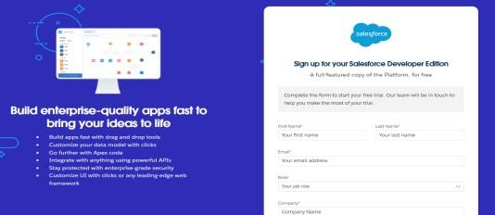

**Fig No.1:** Create a Developer account.

#### Account activation:

Check your email inbox for an activation email from Salesforce. - Click on the Verify Account link. - Set a password and answer the security question. - After changing your password, you will be redirected to the Salesforce setup page.

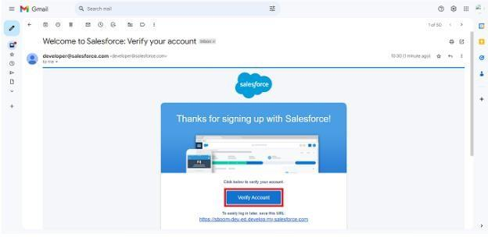

**Fig No.2:** Activation the Developer account.

### Creation of object:

Custom objects in Salesforce act like database tables where you can store specific information related to your business. Here’s how to create them :

1. **Navigate to Object Manager :** -From the Salesforce Setup menu (click on the gear icon), select Object Manager.
2. **Create an Object :** Click Create and choose Custom Object. - Fill in the object details for each type: - Customer Details - Appointment - Service Records - Billing Details and Feedback - For each object, set the following: -

Label: Name of the object (e.g., Customer Details) - Plural Label: Plural form (e.g., Customer Details) - Record Name: Define the primary field for records (e.g., Customer Name for Customer Details) - Data Type: Choose appropriate types (e.g., Text, Auto Number) - Enable options like Allow Reports, Track Field History, and Allow Search. - Click Save to create the object.

### Creating the custom tab

Tabs provide a user interface for accessing custom objects and records.

#### Steps to create custom tab:

* 1. **Navigate to Tabs:** - Go to Setup → Tabs → New (under Custom Object Tabs).
  2. **Create a New Tab:** - Select the object (e.g., Customer Details) from the list. - Choose a tab style and icon to represent the object. - Click Next, configure visibility settings for profiles, and click Save.

#### Repeat for Remaining Objects:

Create tabs for Appointments, Service Records, and Billing Details and Feedback following similar steps.

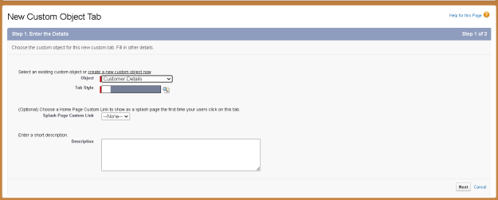

**Fig No.3:** Creation of Custom Object Tabs.

### Create a lightning app:

A Lightning App bundles objects, tabs, and other items together for user access.

#### Steps to create lightning app:

1. **Navigate to App Manager:** Go to Setup → App Manager → New Lightning App.
2. **Configure the App:** App Details: Name your app (e.g., Garage Management Application). - App Options: Choose default settings or customize as needed. - Navigation Items: Add tabs for custom objects (Customer Details, Appointments, etc.). - Utility Items: Configure utility bar settings if required.

- User Profiles: Assign the app to user profiles (e.g., System Administrator).

1. **Save and Finish:** Review the settings and click Save & Finish to complete the app creation.

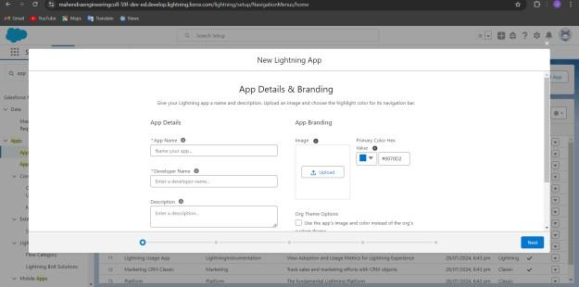

**Fig No.5:** Creation of Lightning App.

### Creation of fields:

Fields represent the data points stored in each object. Custom fields are tailored to your specific needs.

#### Steps to create custom fields:

1. **Navigate to Fields & Relationships:** Go to Setup → Object Manager →

Select the Object (e.g., Customer Details) → Fields & Relationships → New .

1. **Create Field Types:** Text: For fields like Phone Number or Vehicle Number Plate. - Date: For fields like Appointment Date. - Currency: For fields like Service Amount. - Checkbox: For fields like Maintenance Service, Repairs. – Picklist : For fields like Service Status or Payment Status. - Formula: For calculated fields like Service Date (use the formula function to calculate dates based on other fields).
2. **Configure Field Properties:** Set field label, data type, and properties such as required, unique, or read-only as needed. - Click Next, configure field- level security and page layouts, and click Save.

##### Create Lookup Relationships

Lookup relationships link records from different objects, allowing for data integration.

##### Steps to Create Lookup Relationships:

* 1. **Navigate to Fields & Relationships:** Go to Setup → Object Manager → Select the Object (e.g., Appointment) → Fields & Relationships→ New.
  2. **Create a Lookup Relationship:** Select Lookup Relationship as the field type. Choose the related object (e.g., Customer Details for Appointments). Configure the relationship properties and filters. Click Save to establish the relationship.
  3. **Repeat for Related Objects:** Create lookup relationships for other objects (e.g., linking Service Records to Appointments).

### Create Validation rule:

Validation rules ensure data integrity by enforcing certain criteria.

#### Steps to Create Validation Rules:

1. **Navigate to Validation Rules:** - Go to Setup → Object Manager → Select the Object (e.g., Appointment) → Validation Rules → New.
2. **Define Rule Criteria:** - Enter the rule name, description, and criteria for validation. Use formulas to define the conditions that must be met for the data to be valid. Enter error messages to display when validation fails.
3. **Save and Test Rules:** - Click Save to activate the rule. Test the rule by entering data into the system to ensure it works as intended.

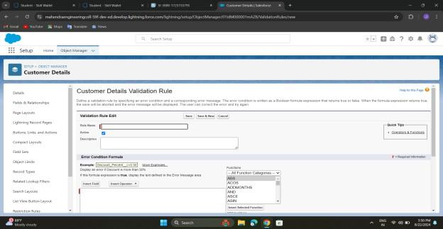

**Fig No.6:** Creation of Validation Rule.

### Create duplicate rules:

#### Steps to create duplicate rules:

* 1. **Navigate to Duplicate Rules:** - Go to Setup → Matching rule → Select the new rule.
  2. **Define rule criteria :** Select object for the required field and give rule name for the duplicate rule and the unique name auto populated and then define the matching criteria for customer details object.
  3. **Save and Test Rules:** - Click Save to activate the rule. Test the rule by entering data into the system to ensure it works as intended.

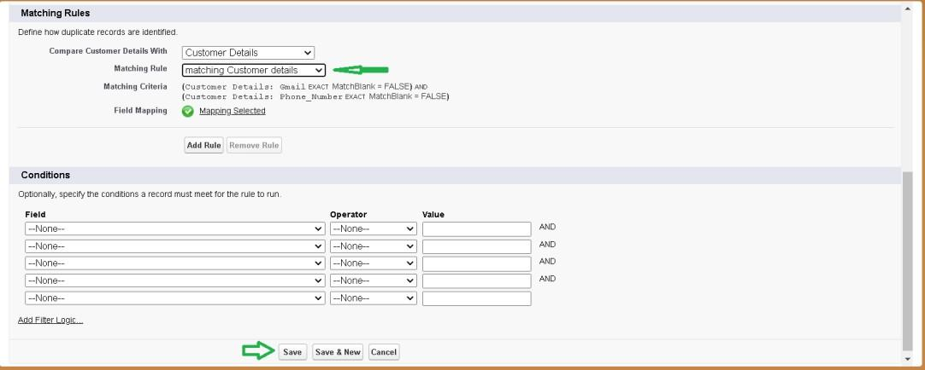

### Create profiles:

**Fig No.7:** Creation of Duplicate Rule.

A profile is a group/collection of settings and permissions that define what a user can do in salesforce.

#### Manager profile

**Steps to create manager profile:**

1. Go to setup **→** type profiles in quick find box **→** click on profiles **→**clone the desired profile (Standard User) **→** enter profile name (Manager) **→** Save.
2. Then click Edit, Select the Custom App settings as default for the Garage management Scroll down to Custom Object Permissions and Give access permissions for Appointments ,Billing details and feedback , service records and customer details objects as mentioned in the below diagram.
3. Then change the session time and user password timeout time and then save.

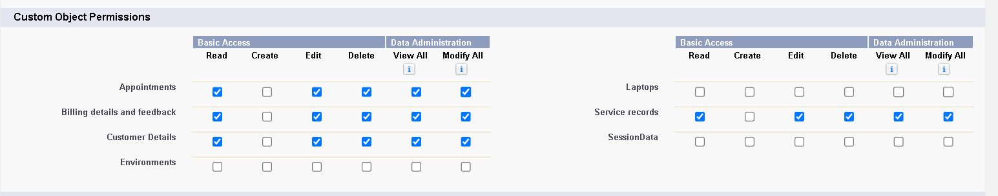

**Fig No.8:** Custom object permission for manager profile.

#### Salesperson profile

**Steps to create salesperson profile:**

1. Go to setup **→** type profiles in quick find box **→** click on profiles **→**clone the desired profile (Salesforce Platform User) **→** enter profile name (Sales person) **→** Save.
2. Then click Edit, Select the Custom App settings as default for the Garage management Scroll down to Custom Object Permissions and Give access permissions for Appointments ,Billing details and feedback , service records and customer details objects as mentioned in the below diagram and then save.

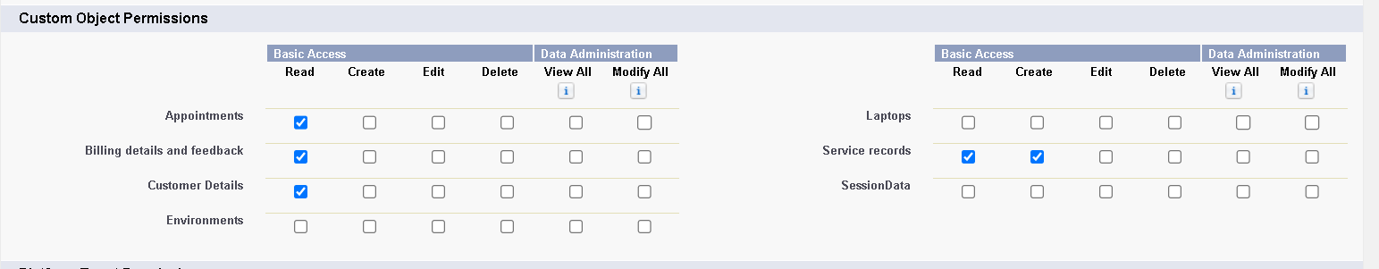

**Fig No.8:** Custom object permission for salesperson profile.

### Configure Reports and Dashboards

Reports and dashboards provide insights and visual representations of data.

#### Steps to Configure Reports:

1. **Navigate to Reports**: Go to Setup → Reports & Dashboards → Reports → New Report.
2. **Create a Report:** Select the report type and configure filters and columns. - Save and run the report to view data.
3. **Create a Dashboard:** Go to Setup → Reports & Dashboards → Dashboards → New Dashboard. - Add components such as charts and graphs to visualize report data.

Configure dashboard settings and share with users as needed.

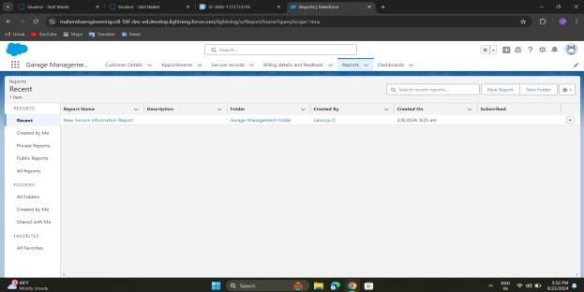

**Fig No.8:** Creation of Reports and Dashboards.

### Set Up Workflow Rules and Automation

Automation helps streamline repetitive tasks and processes.

#### Steps to Set Up Workflow Rules:

* 1. **Navigate to Workflow Rules:** Go to Setup → Workflow Rules → New Rule.
  2. **Define Rule Criteria:** Choose the object and set criteria for triggering the workflow. Define actions such as email alerts, field updates, or task creation.
  3. **Activate Workflow Rule:** Click Save and Activate to enable the rule.

#### Steps to Use Process Builder:

1. **Navigate to Process Builder:** Go to Setup → Process Builder → New Process.
2. **Define Process:** Set up process criteria and actions using a visual interface. - Save and activate the process.

### Customize Page Layouts

Page layouts determine how fields and related information are displayed on record pages.

#### Steps to Customize Page Layouts:

1. **Navigate to Page Layouts:** Go to Setup → Object Manager → Select the Object (e.g., Appointment) → Page Layouts.
2. **Edit Layout:** Drag and drop fields and sections to arrange the layout. Configure visibility settings and field placements. Click Save to apply the layout changes.

### Create and Configure Email Template

Email templates help standardize communication for notifications and updates.

#### Steps to Create Email Templates:

1. **Navigate to Email Templates**: - Go to Setup → Email → Classic Email Templates.
2. **Create Template:** Choose New Template, select type (e.g., HTML), and enter template details. Include merge fields to personalize emails. Save the template and test by sending a sample email.

### Ensure Security and Access Control

Managing user access is crucial for protecting sensitive data and ensuring proper permissions.

#### Steps to Configure Security and Access Control:

* 1. **Navigate to Profiles:** - Go to Setup → Profiles. - Edit profiles to set permissions for objects and fields.
  2. **Use Permission Sets:** - Go to Setup → Permission Sets. - Click New Permission set to create a new set of permissions. - Define the permissions needed (object access, field-level security, etc.). - Assign the permission set to users or groups as necessary. - Click Save to apply the permissions.
  3. **Set Up Role Hierarchy:** - Go to Setup → Roles → Role Hierarchy. - Define roles that reflect your organization’s structure. - Set up roles to control access and data visibility based on user roles. - Assign users to roles to manage their access level accordingly.

### Develop Custom Lightning Components (Optional)

Custom Lightning Components can enhance the user interface and add specific functionalities.

#### Steps to Develop Custom Lightning Components:

1. **Set up Salesforce DX**: - Install Salesforce CLI and configure Salesforce DX for development. - Create a new project using the Salesforce CLI.
2. **Create Lightning Component:** - In your Salesforce DX project, use the command sfdx force:lightning:component:create to create a new component. - Define the component’s functionality using HTML, JavaScript, and Apex (if needed).
3. **Deploy and Test:** - Deploy the component to your Salesforce environment using Salesforce CLI. - Test the component in your Salesforce org to ensure it meets requirements.

### Testing and Deployment

Before going live, thoroughly test your system and deploy it to production.

#### Steps for Testing:

1. **Unit Testing:** Test individual components, objects, and fields to ensure they work as expected. Use Salesforce’s built-in testing tools or create test cases to validate functionality.
2. **User Acceptance Testing (UAT):** Have end-users test the system in a sandbox environment. Collect feedback and make necessary adjustments based on user experiences.
3. **System Testing:** Test the entire system, including integrations, automation, and user interfaces. Ensure that all components work together seamlessly.

#### Steps for Deployment:

1. **Prepare for Deployment:** Review deployment plans and ensure all components are ready for production. Use change sets or Salesforce DX for deployment.
2. **Deploy to Production:** Deploy the system using change sets or Salesforce CLI. Monitor the deployment process and address any issues that arise.
3. **Post-Deployment:** Verify that the system is functioning correctly in the production environment. Provide training and support to users as needed.

### Continuous Improvement and Maintenance

After deployment, ongoing maintenance and improvements are essential to keep the system effective.

#### Steps for Continuous Improvement:

* 1. **Monitor System Performance:** Regularly check system performance and user feedback. - Address any performance issues or bugs promptly.
  2. **Update and Enhance Features:** Periodically review and update features based on evolving business needs. Implement new functionalities and enhancements as required.
  3. **Provide User Support:** Offer training and support to users to ensure they can effectively use the system. Maintain a knowledge base or help resources for user assistance.
  4. **Review Security:** Regularly review and update security settings and access controls. Ensure compliance with data protection regulations and organizational policies.

This document provides a detailed approach to creating a Garage Management System in salesforce. By following these steps, you can effectively manage garage operations and improve overall efficiency 15 and customer satisfaction.

### Output screenshots:

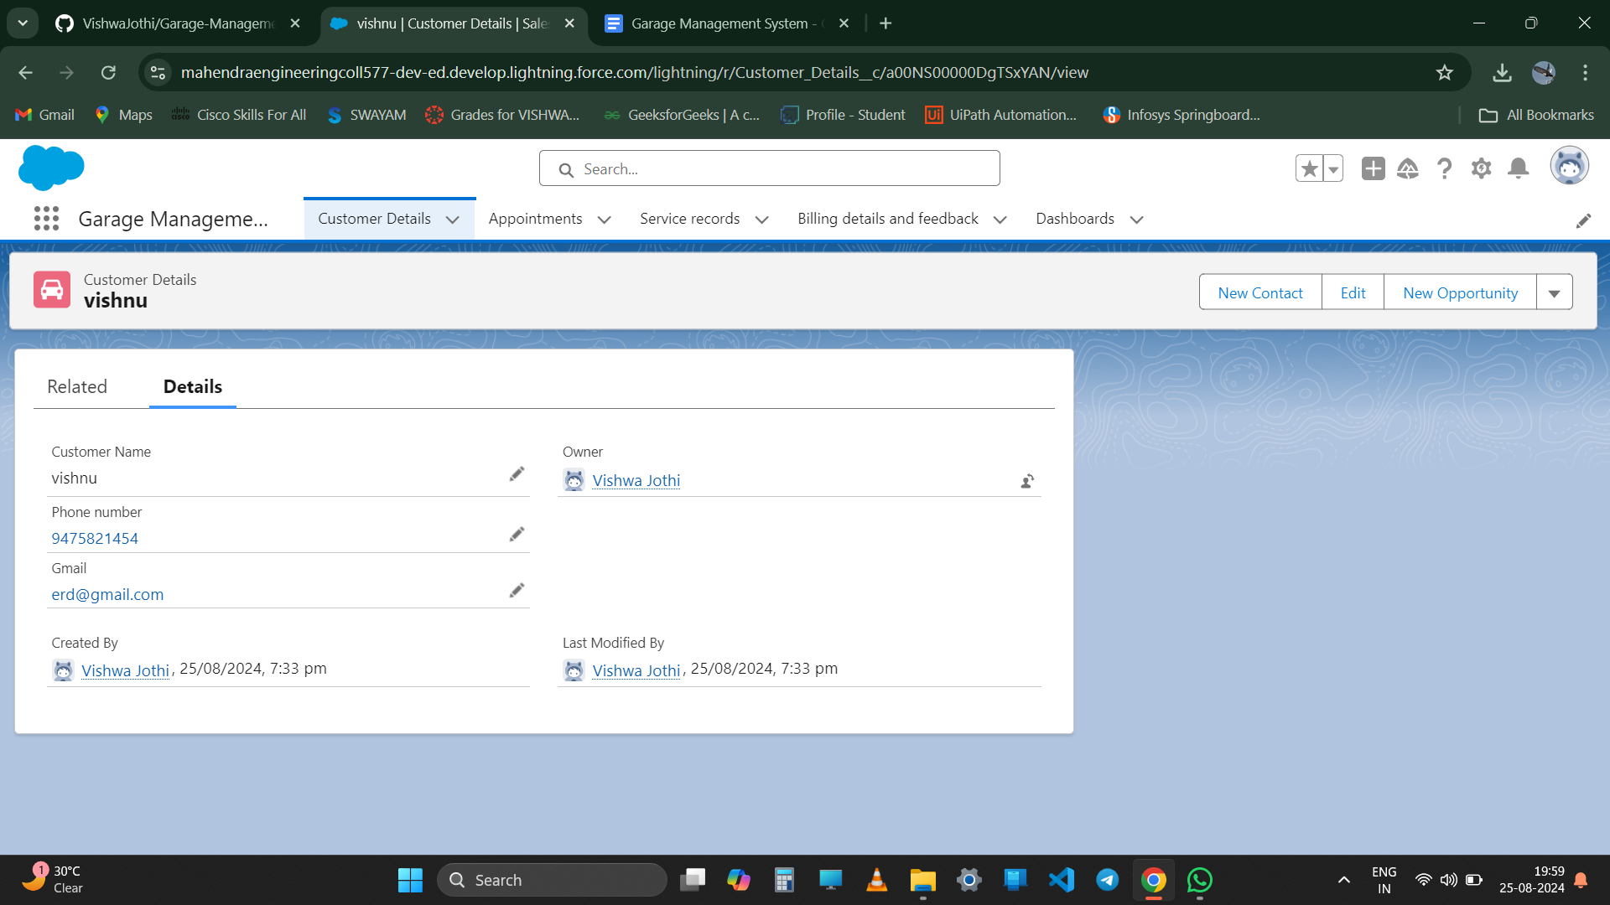

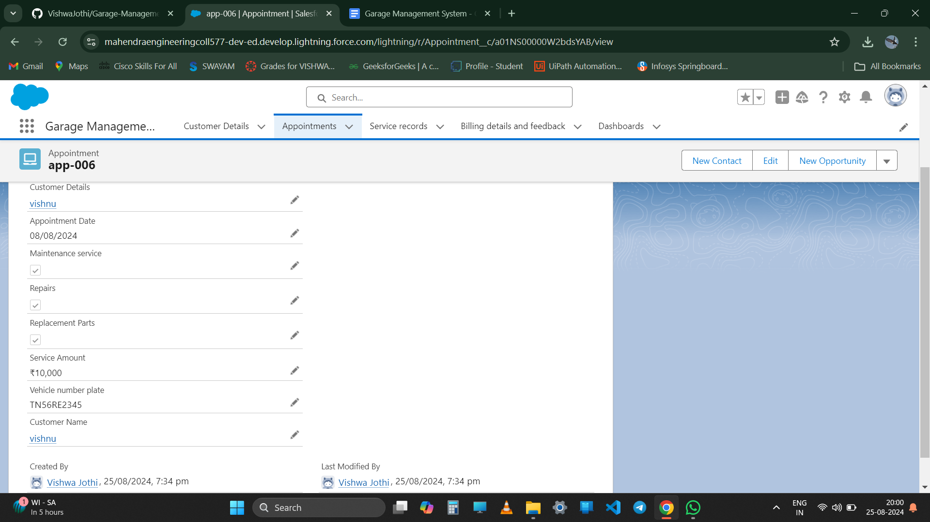

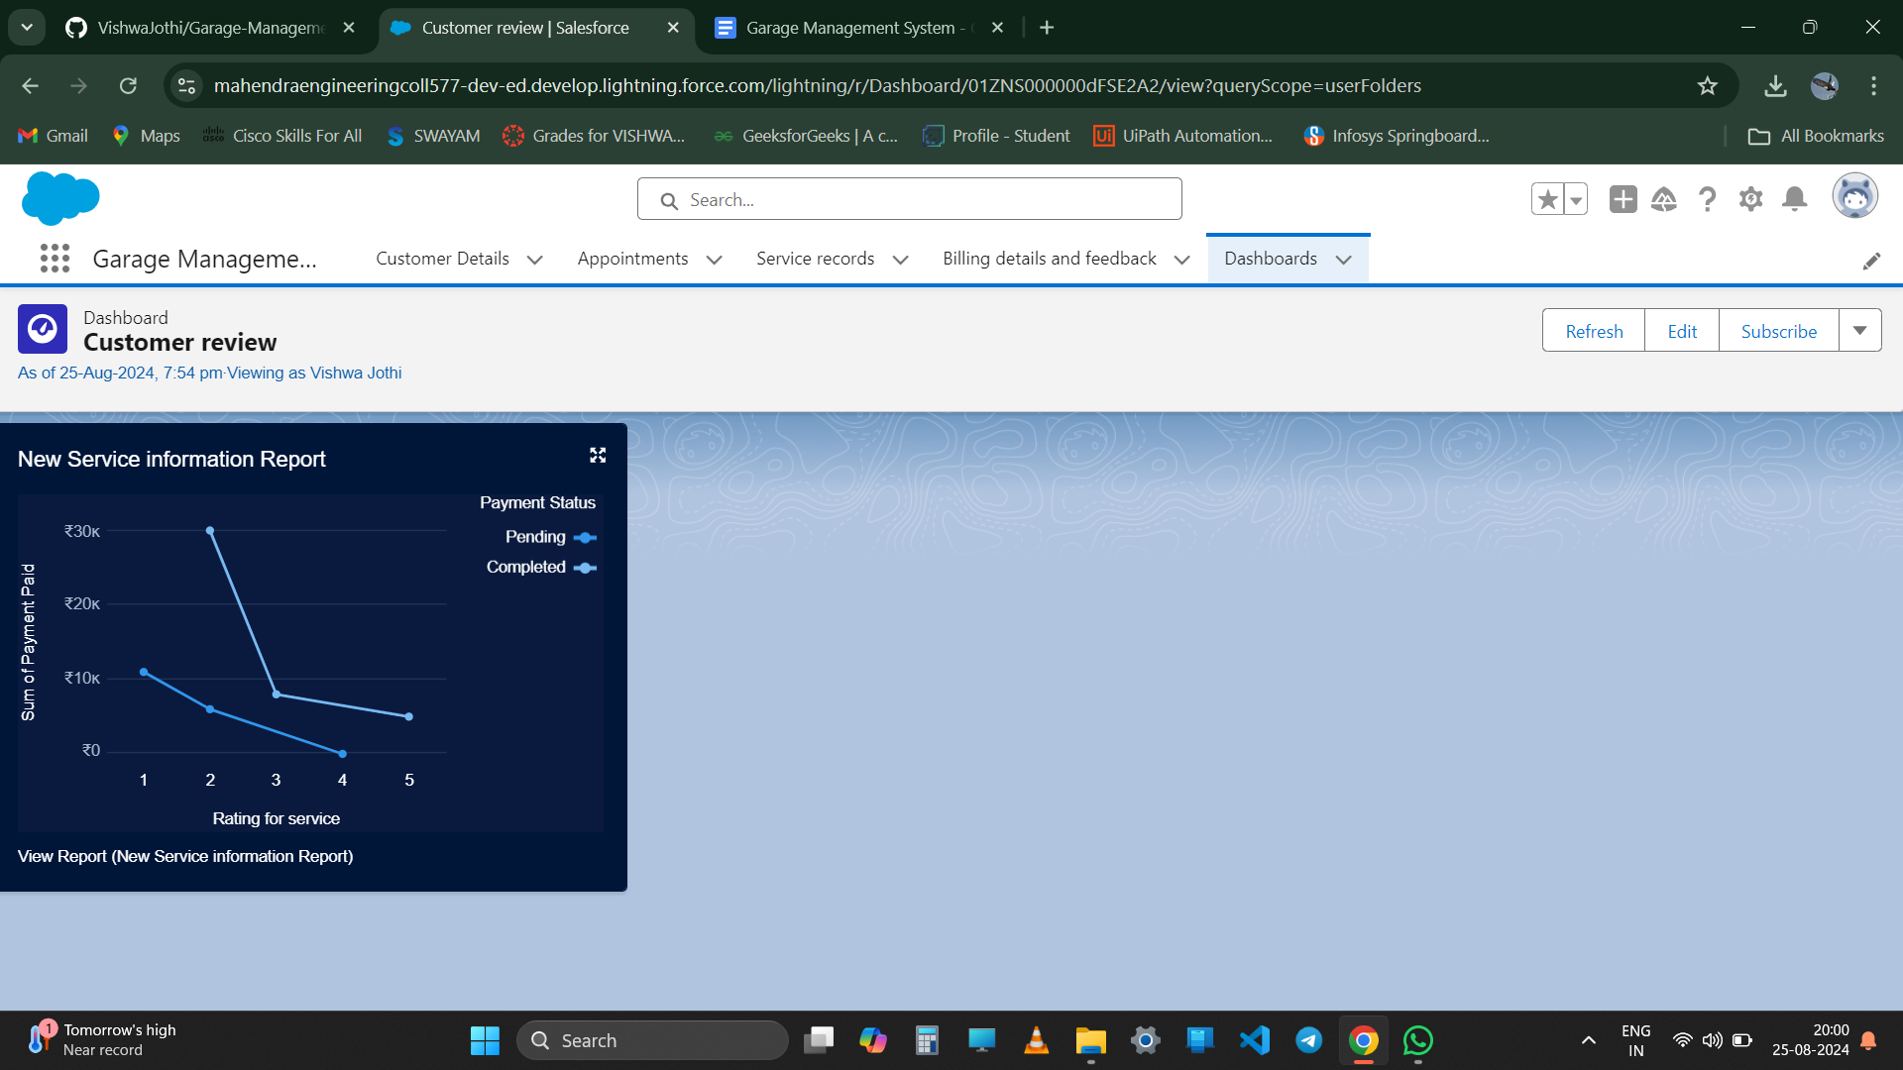

**Conclusion:**

The Garage Management System project has been a comprehensive and enriching experience, demonstrating the power of Salesforce in streamlining business processes and enhancing customer satisfaction. Through this project, we successfully designed and implemented a customized Salesforce solution to manage:

* Customer information and appointments
* Service records and billing details
* Feedback and ratings

Utilizing Salesforce's robust features, including custom objects, fields, validation rules, duplicate rules, profiles, and flows, we created a seamless and efficient system for garage owners to manage their business. The Garage Management System showcases our ability to apply Salesforce skills to real-world business challenges, driving process automation, data analysis, and customer relationship management. This project has not only honed our technical skills but also fostered collaboration, creativity, and problem-solving. As we conclude this project, we are confident that the Garage Management System will serve as a valuable asset for garage owners, empowering them to deliver exceptional customer experiences, drive business growth, and stay ahead in the competitive market. Thank you to our instructors, mentors, and team members for their guidance, support, and dedication throughout this project.